SportsHeadz Instructions to Access your Team or Group

- Download the SportsHeadz App (iPhone or Android)
- Open the app and click Create Account. Click Next. If you have already created an account, please click “Already have an account” at the bottom and sign in (move ahead to Step #4). Complete the following screens and click Finish.
- You will be emailed a verification code to enter in the app.
- Once in the app, click on “Find a Team” or click on blue + in bottom right corner
- Select “I have a code…” and enter the code from the Conditioning Groups list. You will need to repeat these steps for each of your players.
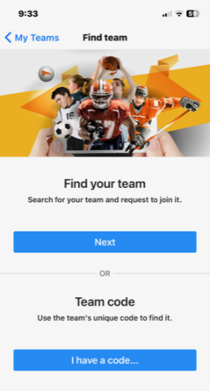
- The team will pop. Press Next.
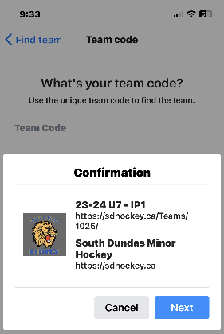

- Select your role and press Next.
Roles:
Parent/Guardian - if you have a child on the team
Fan – if you are a grandparent, friend, relative, etc.
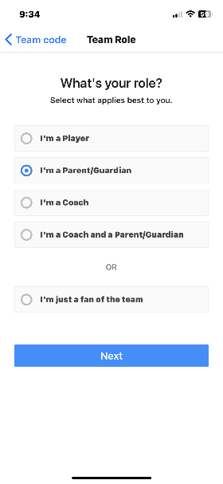

In the next screen, IMPORTANT – please provide players’ name in the notes so you are assigned to the correct player. Press Submit.
The coach/manager will assign you to your player.

