On behalf of your SDMHA Executive, we wanted to share a few tips with you all to ensure everyone is set up for success for our 2023-2024 Hockey Season.
Where is the best place to find hockey schedules for a team?

- Hockey Schedules can be found through the SportsHeadz App once your players have been added
to a team
NOTE: Players are added to their regular season team following tryouts and sorts for all levels
- Schedules can also be found via our website at www.sdhockey.ca
Step 1: Click on Team Finder at the top left-hand corner of the webpage
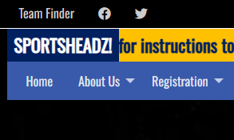

Step 2: From there, select the team that your player will be on. This will take you to the Team
Home Page.
Step 3: Near the bottom of the page will be the team calendar. It is defaulted to show you a 5 day
schedule view. Click on “Full Calendar” to see the full team calendar.
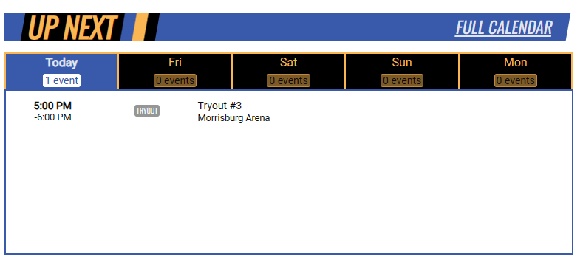

How do I get the team schedules into my other personal calendar?
Would you like to be able to import your team(s) schedules into your other calendars, and automatically sync when those schedules change?
This website provides a Live Calendar "Feed" which allows programs like Microsoft Outlook®, services like Google Calendar™, or devices like the Apple iPhone™ to import and combine with your other calendars. Because it's a "feed" and not a "file" (which you can also export from this site), information changed on the site will automatically update in your other calendar(s).

Step 1: Please refer to Step 3 above to access the “Full Calendar” for the team. From there, you will see the monthly calendar at a glance. Click on “Subscribe” which is on the right-hand side.

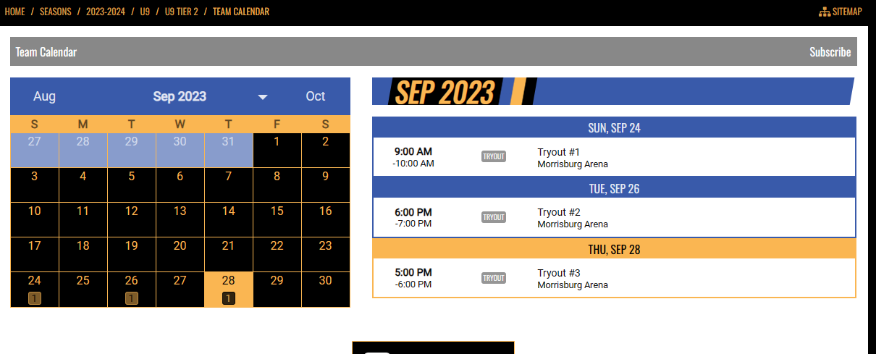

Step 2: From there, follow the 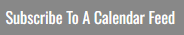 instructions. Please note this
function is only available through our website and NOT through the SportsHeadz App

